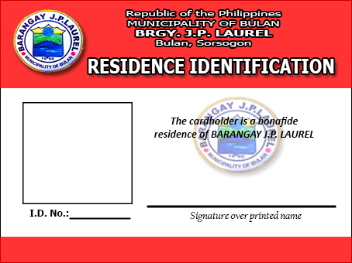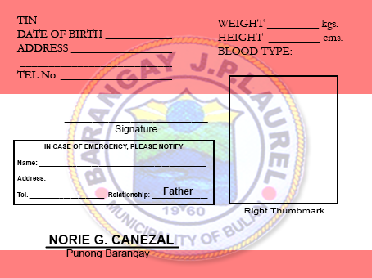

MARITES G. BREZUELA

BULAN, SORSOGON

,BULAN, SOR.

BULAN, SORSOGON

J. P. LAUREL

BULAN, SORSOGON

0930-1818-612

BULAN, SORSOGON

157

BULAN, SORSOGON

40

BULAN, SORSOGON

0935-538-8853

BULAN, SORSOGON

BULAN, SORSOGON

BULAN, SORSOGON

BRGY. J. P. LAUREL

BULAN, SORSOGON

04-12-1996

20191123

MOTHER

BULAN, SORSOGON

SPOUSE

BULAN, SORSOGON

ANGELA BREZUELA